Project Development Phase
Model Performance Test

Date | 21 February 2025
Team ID | PNT2022TMIDxxxxxx
Project Name | PlantCare AI: Advanced Plant Disease Detection using Transfer Learning
Maximum Marks

Model Performance Testing:
Project team shall fill the following information in model performance testing template.
S.No. | Parameter | Values | Screenshot
 | Model Summary | The PlantCare AI system uses a deep learning model based on Transfer Learning with MobileNetV2 / ResNet50 architecture. The model is trained on the PlantVillage dataset containing thousands of plant leaf images. The system processes uploaded leaf images, performs preprocessing, and predicts the plant disease using a trained convolutional neural network. | 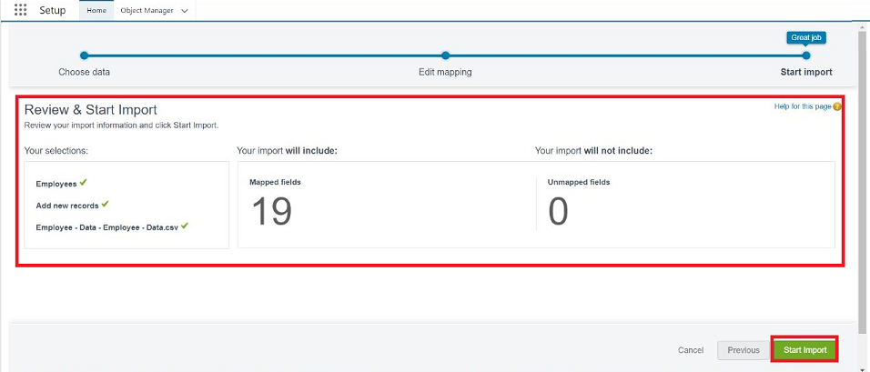
 | Accuracy | Training Accuracy – 96%  Validation Accuracy – 94% | - 
3. | Confidence Score (Only Yolo Projects) | Class Detected – Plant disease class such as Tomato Early Blight, Potato Late Blight, Healthy Leaf.  Confidence Score – The model outputs a probability score indicating prediction certainty. Example: Tomato Early Blight – 92% confidence. | 